 | IQVIATM Work Instruction Review and Coordination of Product  Artwork Labeling
Document Number and Revision:
CS_WI_RA0306 Revision 1
Document Owner  Mariana Cupo | Author(s):  Apparao Chinnam

- PURPOSE
The purpose of this document is to describe the process for coordination and regulatory review of healthcare product artwork.

- SCOPE
This global Work Instruction (WI) applies to all staff within Regulatory Affairs & Drug Development Solutions (RADDS) working on coordination and/or regulatory review of artwork.

- ROLES AND RESPONSIBILITIES

Role | Sections
Regulatory Lead (RL) | 6.1, 6.2
Project Team Member (PTM) | 6.1, 6.2, 6.3, 6.4
Global Labeling Lead (GLL) | 6.1, 6.2

- DEFINITIONS
Draft Artwork: A representation of labeling that demonstrates how the layout and formatting of content will visually appear for a proposed labeling design. (Or) A rough, initial draft of how artwork should be laid out. This includes the initial draft text to be included on first draft of artwork and is primarily used when no previous version of product labeling has been created (e.g., for a new product, new acquisition product). It does not apply to artworks used in clinical trials.
Note: Artwork mock-up can be used as synonymous to draft Artwork
Final Artwork: The image set layout and format of the overall representation of required labeling content, and the frames, borders, crop marks, bleed marks, slug area, headers, and footers that are used to create labeling.
Note: Some companies use the term “issued labeling” for final Artwork.
Redline/Markup: Clear written record of labeling content (derived from labeling requirements) (e.g., text, graphics, images) being created, added, edited or deleted.
Business-Owned Changes: Change to the artwork labels because of a larger business change, i.e., Manufacturing/packaging plant is installing new equipment or updating current equipment and the result is that those products produced on that line require changes to artwork layout and specification, Marketing wants to geographically expand an existing product into another market, region, country, etc.
Label-Only Changes: Change to the label where label content is the primary driver of the change.
Labeling Content: Content of labeling consists of text, tables, and figures inclusive of graphics, images, illustrations, logos, photographs, charts, and symbols that convey information as it relates to the identity and safe and effective use of a

product. This information may be provided in several different formats depending on the type of labeling and/or regulatory need.
Packaging Component: Labeling material that the product is contained within during shipment and/or administration, including labels that are applied to the container of the product. Examples of a packaging component include but are not limited to vial labels, bottle labels, individual cartons, intermediate cartons, tertiary cartons, shipping labels.
Package Leaflet: Document that contains instructions on the intended use, how to dose, warnings and precautions, adverse reactions, and other important product information. This document is generally written for medical professionals, except for the Patient Information Leaflet (PIL), which is written for patients. Examples of this package leaflet include but are not limited to: IFU, Directional Insert, Operator’s Manual, Product Monograph, Summary of Product Characteristics (SmPC), Patient Information Leaflet (PIL), etc.

- MATERIAL AND EQUIPMENT
Not Applicable

- PROCEDURE

  - Review and coordination: New Artwork

No: | Who: | Step: | When:
6.1.1 | RL | Generates a request in Artwork management system or sends an email request to PTM for a new Artwork. | After receiving request for new Artwork from customer
6.1.2 | PTM | - Requests input from customer cross- functional teams (e.g., CMC, Labeling, Medical and Safety) for the Artwork text.  - Coordinates deadlines with printing site | After receipt of request for new Artwork
6.1.3 | PTM | Sends the texts and the inputs received from cross-functional SMEs to Artwork Designing and Creation Team for creation of new Artwork | After receiving inputs from cross-functional SMEs
6.1.4 | PTM | Sends the draft Artwork for review to Global Labeling Lead (GLL) | After receiving draft Artwork
6.1.5 | GLL | - Reviews the Artwork for content against the agreed/ approved texts, formatting and country/ regional requirements.  - Sends the review feedback to PTM. | After receiving the draft Artwork for review
6.1.6 | PTM | - If the draft Artwork needs correcting, sends the comments to Artwork Designing and Creation Team.  - If the draft Artwork does not need correcting, sends the Artwork for approval to cross- functional SMEs or as per customer’s process. | After receiving review feedback from GLL

6.1.7 | PTM | Collects approval from cross-functional SMEs | After finalizing the Artwork content
6.1.8 | RL | Closes the new Artwork creation request | After cross-functional SME approval

  - Review and coordination: Update to Artwork

No: | Who: | Step: | When
6.2.1 | RL | Generates a request in Artwork management system or sends an email request to PTM for a new Artwork. | Upon receipt of customer request for Artwork review.
6.2.2 | PTM | Requests the RL to provide the draft artworks or coordinate with the customer point of  contact for the draft artworks to review | After receipt of request for Artwork review
6.2.3 | PTM | Sends the draft Artwork for review to Global Labeling Lead (GLL) | After receiving draft Artwork(s)
6.2.4 | GLL | - Reviews the Artwork for content, formatting and country/ regional requirements.  - Sends the review feedback to PTM. | After receiving the draft Artwork for review
6.2.5 | PTM | - If the draft Artwork needs correction, sends the comments to Artwork Designing and Creation Team  - If the draft Artwork does not need correcting, sends the Artwork for approval to cross- functional SMEs or as per customer’s process. | After receiving review feedback from GLL
6.2.6 | PTM | Collects approval from cross-functional SMEs | After finalizing the Artwork content
6.2.7 | RL | Closes the new Artwork creation request | After cross-functional SME approval

  - Change Control Tracking
All changes to labeling require Change Control management.

No: | Who: | Step: | When:
6.3.1 | PTM | Initiates the Change Control record in the database as per the project instructions | When a new request is sent for creation or update to Artwork

  - Communication and Submission of new/updated local/regional product labels

No: | Who: | Step: | When:
6.4.1 | PTM | Share the final artwork with the concerned stakeholders (submission team or customer POC) | After receipt of approval from cross-functional SME’s

- SUPPORTING DOCUMENTATION
DOCUMENT NUMBER | TITLE
Not Applicable | Not Applicable

- SUPERSEDES
DOCUMENT NUMBER | TITLE | REVISION  NUMBER
Not Applicable | Not Applicable | Not Applicable

- MODIFICATION FROM PREVIOUS REVISION
CHANGE | SECTION REFERENCE | JUSTIFICATION
This is a New Document | Not Applicable | Process was not previously described for marketed products (Post-registration).

- APPENDICES

  - Appendix A: Process flow for Review and coordination: New Artwork

  - Appendix B: Process flow for Review and coordination: Update to Artwork

  - Appendix A: Process flow for Review and coordination: New Artwork

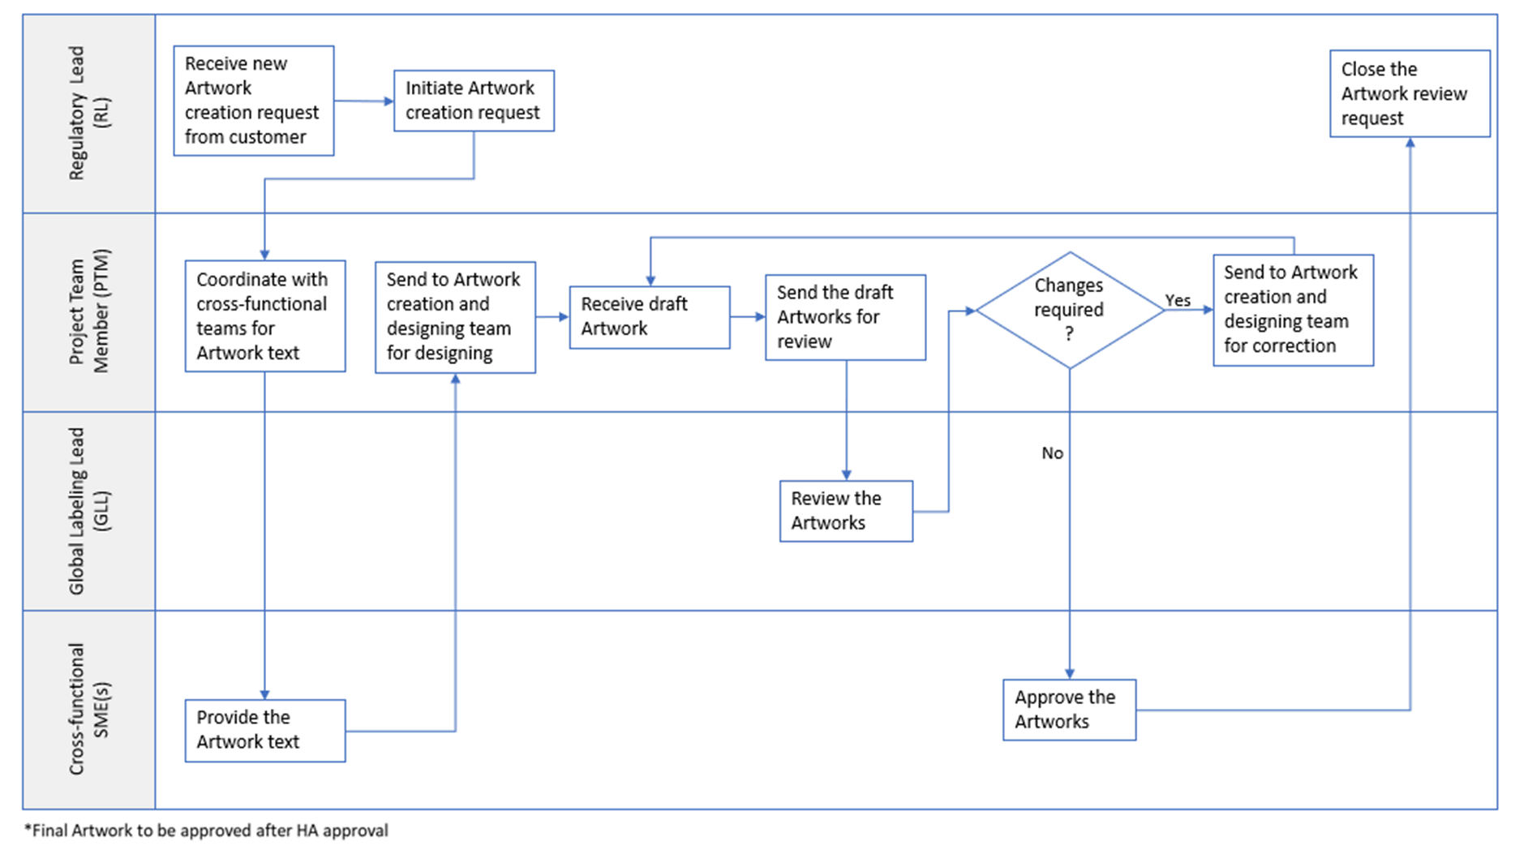

  - Appendix B: Process flow for Review and coordination: Update to Artwork

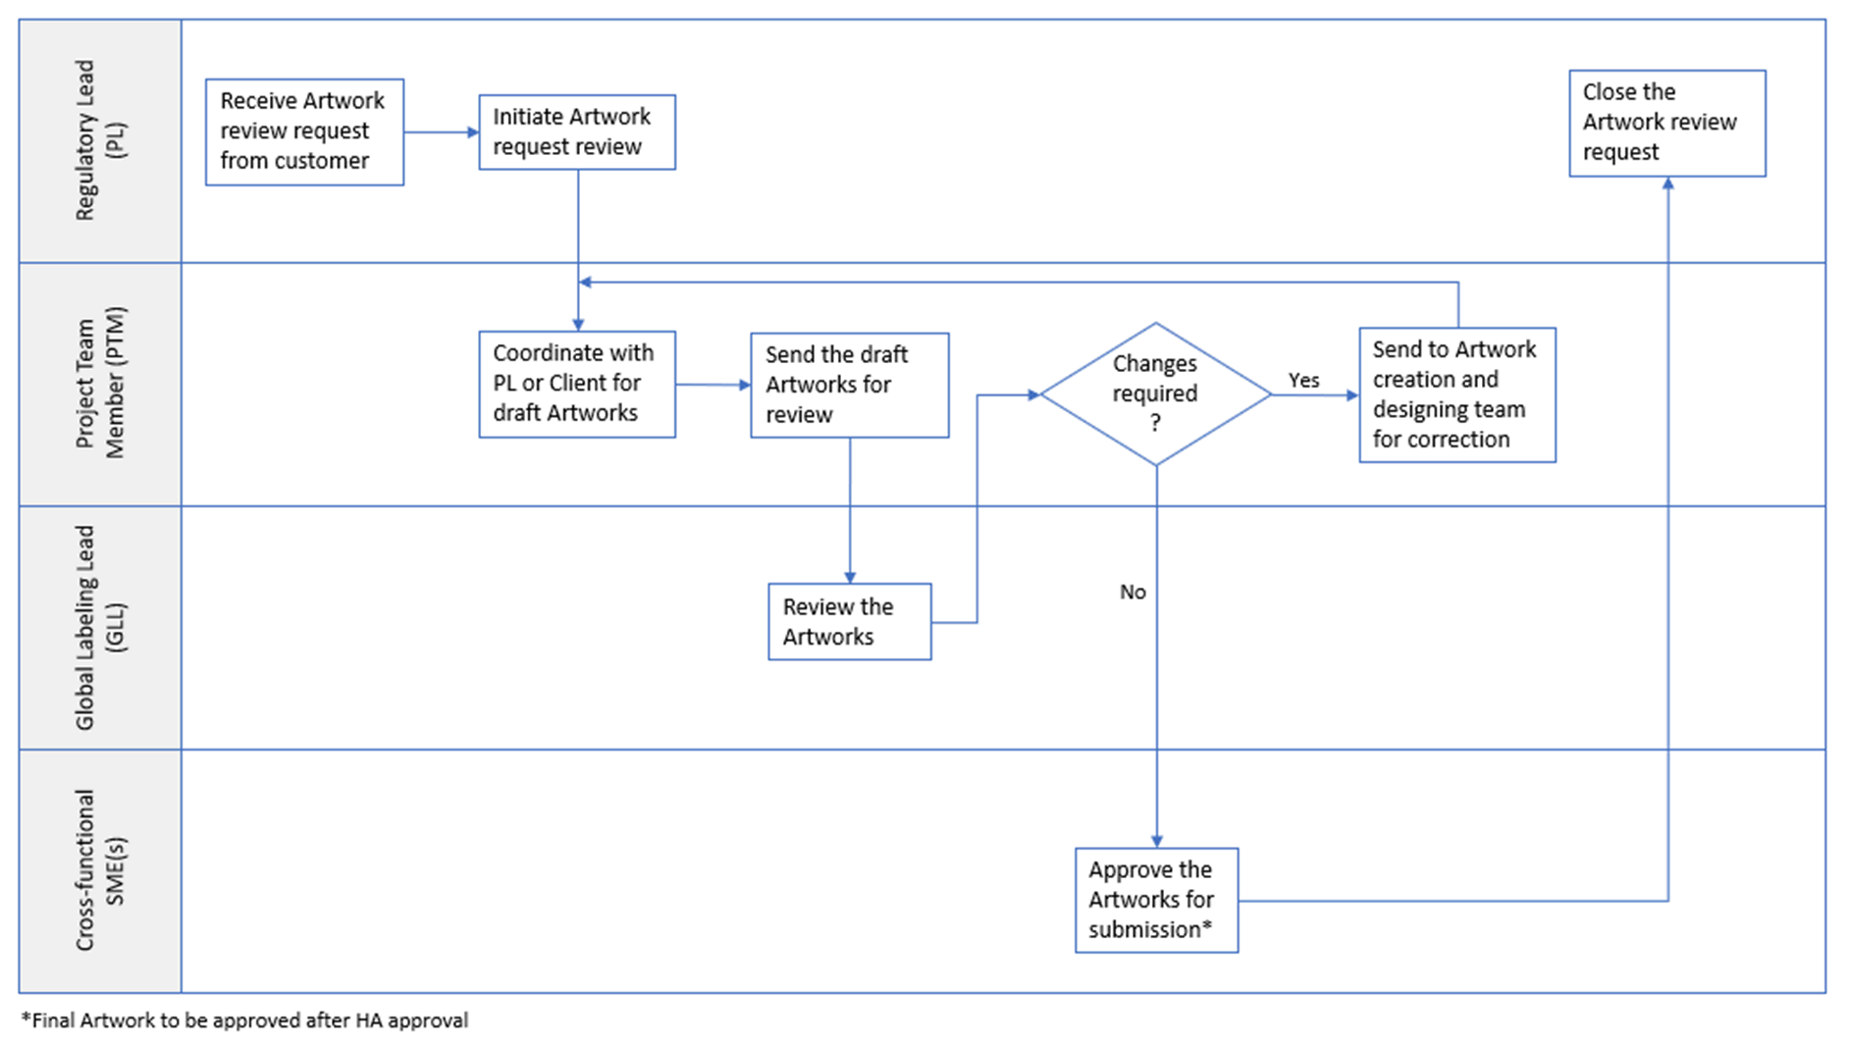

Page 6 of 6
Copyright © 2023 IQVIA. All rights reserved. The contents of this document are confidential and proprietary to IQVIA Holdings Inc. and its subsidiaries. Unauthorized use, disclosure or reproduction is strictly prohibited.

Standard Operating Procedure Approval Signature(s)
This is a representation of an electronic record that was signed electronically in Content Server.
This page is the manifestation of the electronic signature(s) used in compliance with the organization’s electronic signature policies and procedures
Refer to Signatories CV for Business Title.

UserName: Singh, Priti (q823374) Title:
Date: Wednesday, 25 January 2023, 08:12 AM Eastern Daylight Time Meaning: Signing this Document Indicates My Approval
================================================

UserName: NAJI, Kenza (u1090913) Title:
Date: Wednesday, 25 January 2023, 08:51 AM Eastern Daylight Time Meaning: Signing this Document Indicates My Approval
================================================

UserName: Schreiber, Cindy (q831321) Title:
Date: Wednesday, 25 January 2023, 10:45 AM Eastern Daylight Time Meaning: Signing this Document Indicates My Approval
================================================

UserName: Murphy, Kendra (q847871) Title:
Date: Wednesday, 25 January 2023, 02:35 PM Eastern Daylight Time Meaning: Signing this Document Indicates My Approval
================================================

UserName: Caldas, Guilherme (q806174) Title:
Date: Friday, 27 January 2023, 12:23 PM Eastern Daylight Time Meaning: Signing this Document Indicates My Approval
================================================

